**Hypothesis Testing of Flipkart’s Delivery and Order Quantity Claims using Excel**

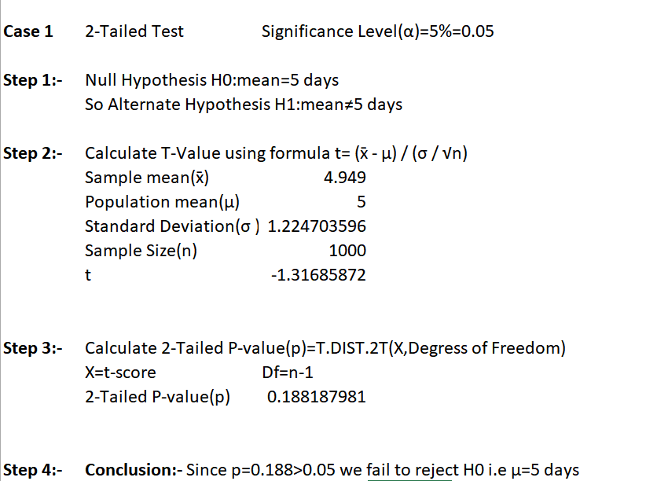

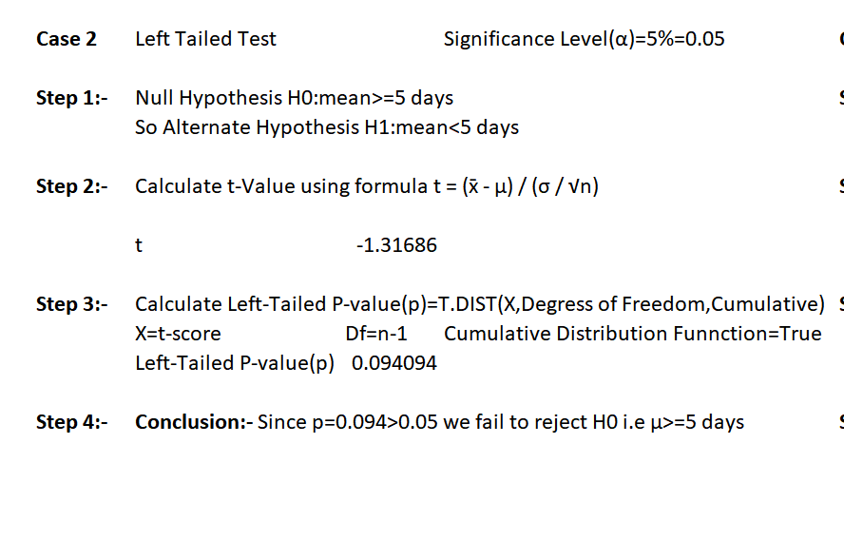

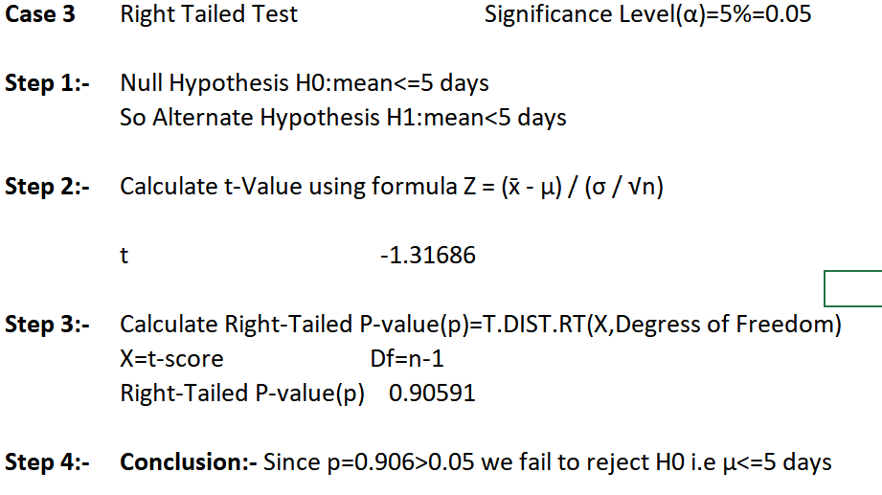

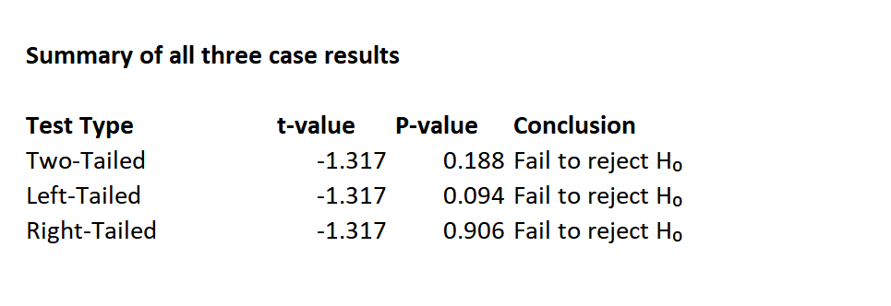

**Final Interpretation:**

* **There is insufficient evidence** to conclude that the average delivery time is different from 5 days
* The sample mean of 4.949 days is **not statistically significantly different** from the hypothesized 5 days at the 5% significance level
* Flipkart's delivery time appears to be **approximately 5 days** on average based on this sample

**Note:** The negative t-value indicates the sample mean is slightly less than the hypothesized mean, but not enough to be statistically significant.



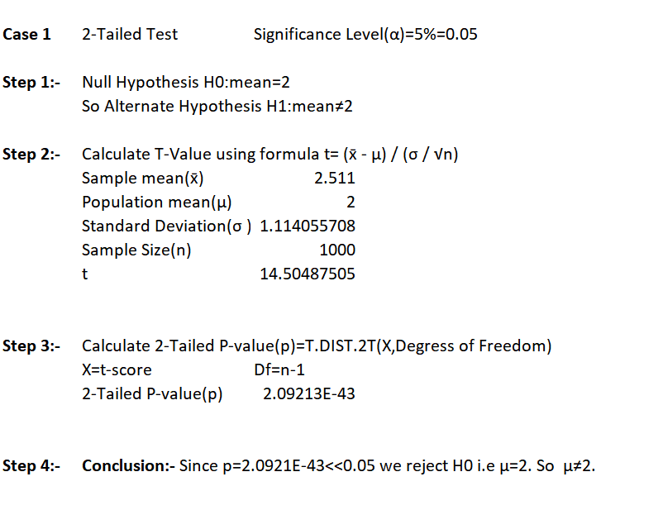

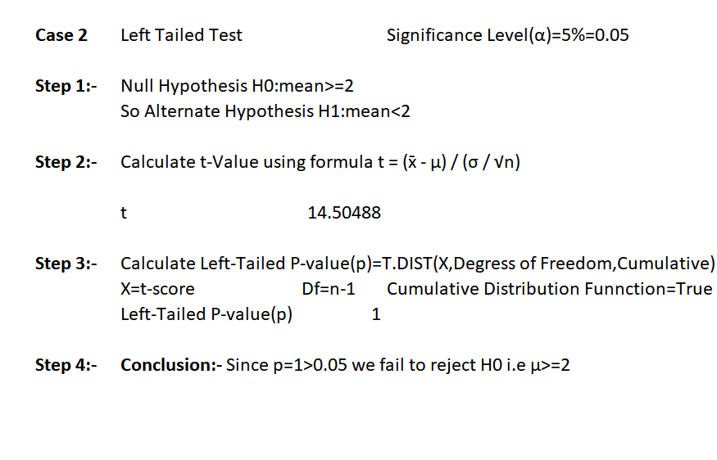

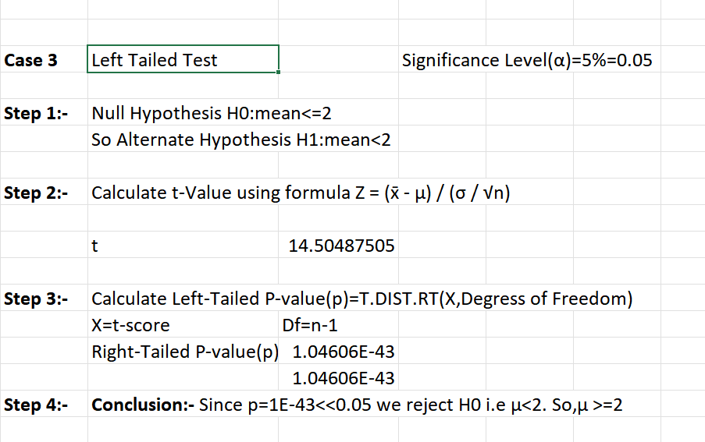

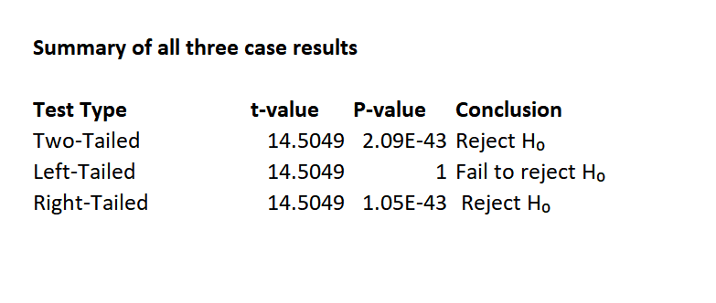

**Final interpretation:**

* **There is sufficient evidence** to conclude that the average quantity ordered is different from 2 items as claimed by Flipkart
* The sample mean of 2.511 items is **statistically significantly different** from the hypothesized 2 items at the 5% significance level
* Flipkart's quantity ordered appears to be **approximately 2.5 items** on average based on this sample

**Conclusion:**

Delivery times averaged 4.95 days vs. claimed 5 days (no statistically significant difference, p ≈ 0.19), while quantities averaged 2.51 vs. claimed 2 items (significantly higher, p < 0.001), providing management with reliable insights into operational efficiency and customer buying behaviour.